LOST
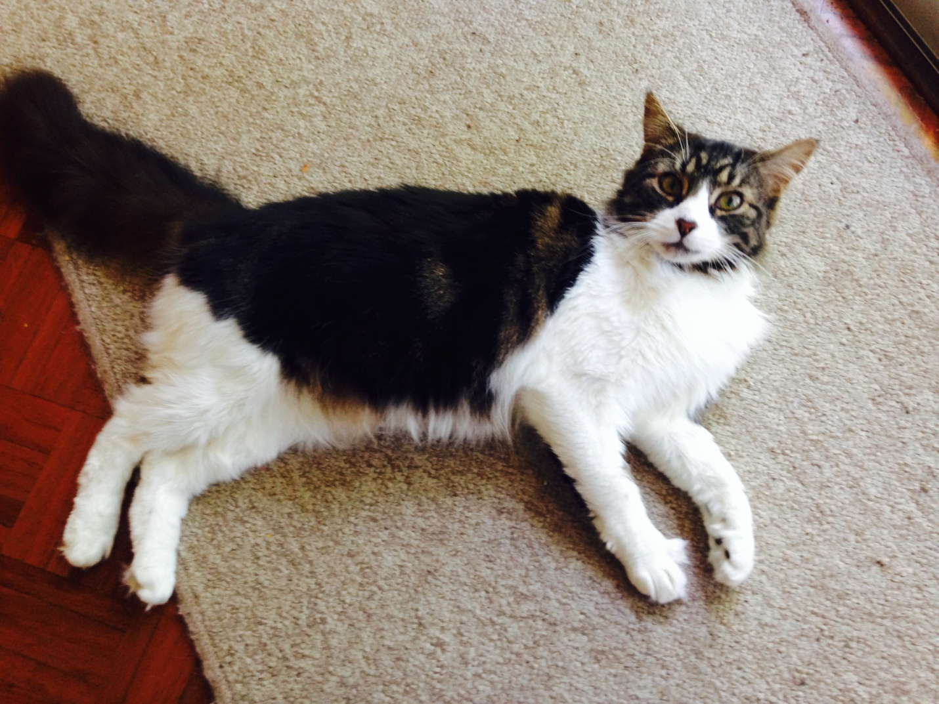

0400 000 000
NAME is our very loved cat missing from SUBURB. Please ring if you think you have seen her - female, desexed and is microchipped.

